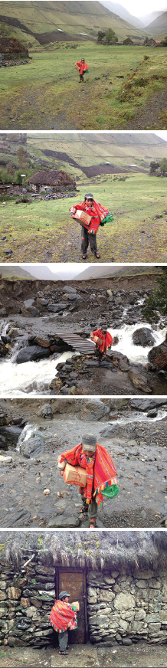
Chickens for Families

One of the biggest challenges facing the people living in these areas is the extremely high rate of child malnutrition. PASKAY helps to combat this by providing chickens as a source of protein for local families.

Thanks to our sponsors, now many poor families of the Sacred Valley are receiving little chickens; they are very excited to be breeding them!

As Carlos relates, “The agreement with the mothers is, first we give to the mother baby chickens, the mothers have to feed and take care of chickens, when the chickens start laying eggs, the mothers have to bring the eggs to the school where their children study, so the children have a good lunch with those eggs.”

“It is very touching to see how these beautiful people take care of their little chickens, putting them in a cardboard box when it is cold outside, taking them out to the sun in nice day, making remedies with medicine plants when the chickens get sick.”

By contributing to the “Chickens for Families” program, you are helping a family towards their goal of self-sufficiency. Breeding chickens and collecting the eggs will give them a continuous, quality source of dietary protein.

Thank you for giving a family in need the most precious of gifts – an opportunity to help themselves!

*PASKAY is a Peruvian Quetchua word which means breaking the bonds of limitations and poverty in order to reach one’s potential.

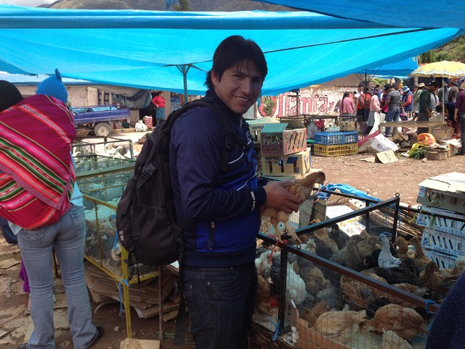
Lorenzo walking the chickens Home

Carlos at the market

