Michelle Gerdes

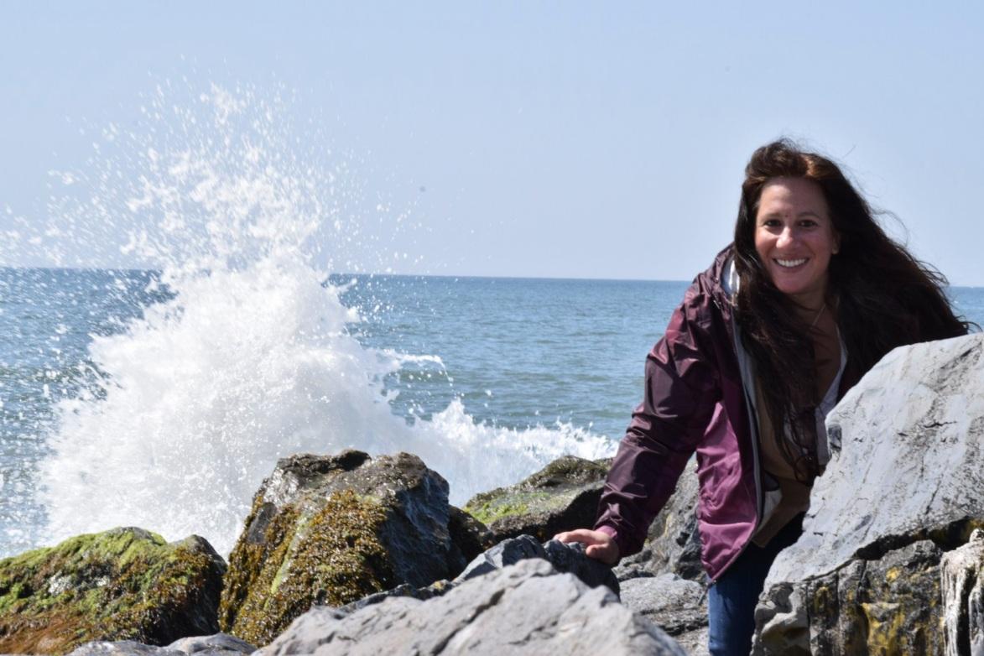

I feel honored to contribute with a team that works to uplift community and children
I have an associates degree in psychology, certification in yoga instruction, and reiki.
Professionally I have worked for 20 years to correct vision needs in the optical field .
My greatest work is of the heart.
Life has taught me, we all have something to contribute.
What is small to one, can make a tremendous difference in the life of another.
All you need to give comes from the heart.

A quote I live by is the words of Mother Teresa...
It's not how much we give, but how much love we put into giving.

Here with Paskay my work is from the heart.

